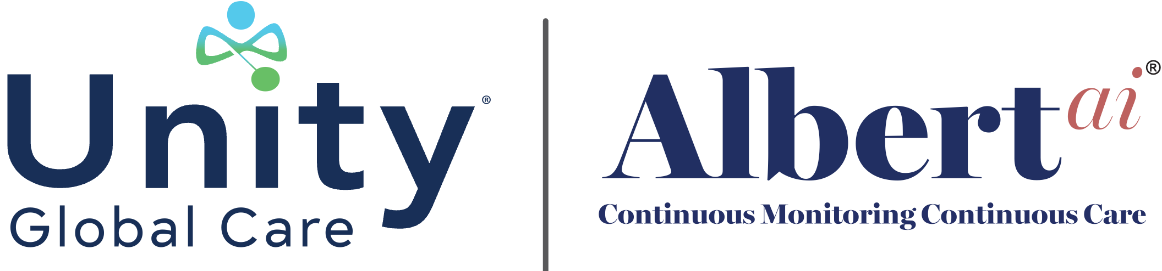

Closing the Gap Between Wearing a Device and Truly Knowing: How PacSana and ALBERTai Are Redefining Safe Aging in Place
By David S. DuPlay, Co-Founder & CEO Unity Global Care Inc. & Feargal Duignan, Founder & CEO, PacSana

There is a moment that happens in almost every family caring for an aging loved one, whether they lives three miles away or three states away. It is the moment when a phone rings and before a single word is spoken, the heart already knows somethings wrong. Was it a fall? A trip to the emergency room? A sudden change no one saw coming? For millions of families, that fear is constant, quiet, and exhausting. And for home care agencies serving those families, the challenge is just as real: how do you protect someone twenty-four hours a day when your caregivers can only be present for a fraction of those hours?
This is the question that brought our two companies together, and it is the question at the center of everything we have built.
Unity Global Care created ALBERTai to solve a problem that has confounded the home care industry for decades: agencies and families are surrounded by information, but starved for insight. A caregiver's notes from Tuesday's visit, a family member’s observation over the weekend, a nurse's report after a hospital discharge, these fragments exist, but they rarely connect into a single, coherent picture of how a person is actually aging over time. ALBERTai was designed to change that. Using artificial intelligence to synthesize these fragments of data into something clear, predictive, and actionable: the patent pending Aging-in-Place Score®. However, in any intelligence platform, no matter how sophisticated, is only as powerful as the data it has available. This is where PacSana became essential to the mission.
PacSana set out to solve a different but deeply related problem. Older adults do not want to feel monitored, managed, or medicalized in their own homes. They want to live their lives. So PacSana built a smart wearable band unlike anything that came before it, one that disappears into daily life rather than disrupting it. There is no smartphone to pair, no daily charging routine to remember, no bulky device to resist wearing. The band is fully waterproof, so it stays on through a shower or a swim, and it runs for a full year on a single charge. For an aging adult, it simply becomes part of life, no different than a wristwatch. For a family or a care team, it becomes something far more valuable: a quiet, continuous witness to the rhythms of daily life.
What makes this partnership powerful is not the wearable alone, and it is not the intelligence platform alone. It is what happens when the two are joined together. PacSana's Smart Band captures the kind of behavioral data that has historically been invisible to home care agencies and families alike. It tracks Active Minutes, reflecting the basic movements of dressing, washing, and moving through the day. It measures Gait Speed, a clinically validated indicator that research has repeatedly linked to fall risk, frailty, and cognitive health. It distinguishes true exercise from ordinary movement, both inside and outside the home. It monitors sleep duration and nighttime bed exits, offering insight into a dimension of health that is often the earliest to shift when something is wrong. And it provides immediate alerts for falls, wandering, and other urgent events, the moments when seconds matter most.
On their own, these data points are useful. Fed into ALBERTai, they become something else entirely. ALBERTai takes this continuous stream of behavioral data from PacSana and layers it alongside caregiver observations, family input, and agency records, building a longitudinal understanding of what is truly normal for each individual person. It does not simply flag that something happened. It learns the baseline of a life, so that it can recognize when that baseline begins to shift, often weeks before a crisis would otherwise reveal itself. A gradually slowing gait. A pattern of restless nights. A quiet decline in movement that no single visit would ever catch. These are precisely the signals that the current healthcare and home care systems are built to miss, and precisely the signals that the Aging-in-Place Score is built to catch.
For home care agencies, this partnership represents a fundamental shift in what it means to provide care. Instead of relying solely on the hours a caregiver is physically present, agencies now have a continuous thread of insight running through the hours in between. The Aging-in-Place Score gives care teams a clear, color-coded view of every client across their entire census, distinguishing those who are stable from those who need a closer look and those who need immediate attention, along with the specific reasons behind each change. This allows agencies to intervene earlier, staff more intelligently, and demonstrate real, documented oversight to hospitals, rehabilitation centers, and referral partners who increasingly expect proof that a client discharged home is not simply left alone. In an industry facing an unprecedented wave of demand, with 10,000 Americans turning 65 every day, this is not a luxury. It is quickly becoming the standard of care that families and referral partners will come to expect.
For families, the significance is even more personal. It means the daughter who lives two states away no longer must rely solely on a phone call to know how her father is really doing. It means the son who visits every Sunday can see, between visits, whether his mother's sleep has changed or her movement has slowed, long before it becomes obvious when present. It means that instead of living in a state of low-grade, constant worry, families can rely on real information, updated continuously, interpreted clearly, and delivered before a small concern becomes a serious one. This is not about replacing human care or human connection. It is about giving both professional caregivers and family caregivers something they have never reliably had before: the ability to see what was previously invisible.
We built this partnership on a shared belief that independence for aging adults, peace of mind for families, and better outcomes for care providers are not three separate goals in competition with one another. They are the same goal, and they are only achievable together. A wearable device that captures meaningful data is only as useful as the intelligence that interprets it. An intelligence platform is only as powerful as the quality and continuity of the data feeding it. PacSana and ALBERTai, joined together, close that loop completely.
Aging in place, safely and with dignity, has always been the outcome that older adults want most and families fear they cannot guarantee. For the first time, agencies and families do not have to choose between reactive care and true independence. They can have both, continuously, quietly, and reliably, in the place every person deserves to feel most at home.

About the Authors:
Feargal Duignan, Founder & CEO, PacSana
Feargal Duignan is a health-tech entrepreneur and the Founder and CEO of PacSana. PacSana is a remote care platform designed to transform senior living and home care. With over two decades of experience in technology leadership, Duignan has dedicated his recent career to addressing critical inefficiencies in eldercare through proactive, data-driven solutions.
After spending years in high-value complex technology sales Feargal founded PacSana. The company develops wearable technology and remote care solutions, specifically the PacSana Smart Bracelet, and AI-driven monitoring software. This technology tracks gait, falls, exercise, sleep, and location to provide care networks with an accurate picture of an individual's changing needs.
David S. DuPlay, Co-Founder, President & CEO, Unity Global Care

Dave brings a uniquely informed perspective to the conversation around aging, technology, and compassionate care. A patient advocate, entrepreneur, and seasoned healthcare strategist with more than 30 years of experience working alongside medical professionals, research organizations, and patient communities across virtually every disease area, Dave has dedicated his career to aligning the goals of all healthcare stakeholders in service of better patient outcomes. As Chairman of Vital Options International, a global health foundation founded in 1983 and committed to health education, advocacy, and financial assistance for patients in minority and underserved communities worldwide, Dave understands firsthand the human stakes embedded in every healthcare decision.

A recognized author and speaker on the challenges facing vulnerable populations, Dave is a passionate believer that technology, when thoughtfully applied, has the power to close gaps in care, amplify the voices of those too often left behind, and preserve the dignity of aging individuals and the families who love them. It is through this lens that Dave Co-Founded Unity Global Care Inc., to bring the ALBERTai eco-system to families and providers, not merely as tools of convenience, but as meaningful instruments of empowerment for some of the most emotionally complex moments families will ever face.

